1. What is SDLC?

SDLC is a structure imposed on the development of a software product

that defines the process for planning, implementation, testing,

documentation, deployment, and ongoing maintenance and support.

There are a number of different development models **Waterfall, Agile Iterative, Spiral, V-shaped**.

2. What is software testing?

Software Testing is a process used to identify the Correctness, Completeness and quality of developed computer software.

3. What is agile methodology?

Agile SDLC model is a combination of iterative and incremental process models with focus on process adaptability and customer satisfaction by rapid delivery of working software product. Agile Methods break the product into small incremental builds. These builds are provided in iterations.

**The Agile software development methodology** is one of the simplest and effective processes to turn a vision for a business need into software solutions. Agile is a term used to describe software development approaches that employ continual planning, learning, improvement, team collaboration, evolutionary development, and early delivery. It encourages flexible responses to change.**Each iteration typically lasts from about one to three weeks.**

4. What is SRS

A software requirements specification (SRS) is **a document that describes what the software will do and how it will be expected to perform** software or application. In simple words, SRS document is a manual of a project provided it is prepared before you kick-start a project/application. This document is also known by the names SRS report, software document. A software document is primarily prepared for a project, software or any kind of application.

There are a set of guidelines to be followed while preparing the software requirement specification document. This includes the purpose, scope, functional and non-functional requirements, software and hardware requirements of the project. In addition to this, it also contains the information about environmental conditions required, safety and security requirements, software quality attributes of the project etc.

* SRS Two Types

1. Product Based **Example Atul motors**
2. Project Based Example Local Company

5. What is OOPS?

Object Oriented Programming (OOP) is **a computer programming model that organizes software design around data, or objects, rather than functions and logic**. An object can be defined as a data field that has unique attributes and behavior.

6. Write Basic Concepts of OOPS

Object, Class, Encapsulation, Inheritance, Polymorphism, Overriding, Overloading, Abstraction

7. What is object?

Any entity which has own state and behaviour. For example, a car can be an object. If we consider the car as an object then its properties would be – its colour, its model, its price, its brand, etc. And its behaviour/function would be acceleration, slowing down, gear change.

8. What is class?

Collection of object called a class. An object is a particular instance of a class which has actual existence and there can be many objects (or instances) for a class. In the case of a car or laptop, there will be a blueprint or design created first and then the actual car or laptop will be built based on that. We do not actually buy these blueprints but the actual objects.

9. What is encapsulation?

Wrapping up of data or binding of data for example Wrapping small five tablet in add to big new tablet

10. What is inheritance? When one object acquires all the properties and behaviour of parent class Example father and son

11. What is polymorphism? Polymorphism means “having many forms”. It allows different objects to respond to the same message in different ways, the response specific to the type of the object. The most important aspect of an object is its behaviour (the things it can do).A behaviour is initiated by sending a message to the object (usually by calling a method) Many ways to perform anything.

* There are two types of polymorphism in Java 1.Method Overloading Name will be same but object are different Compile time polymorphism (Overloading) for example how are you

2. Method Overriding Name and object same data will be replays Runtime polymorphism (Overriding) for example Replay fine

12. Draw used case on online book shopping

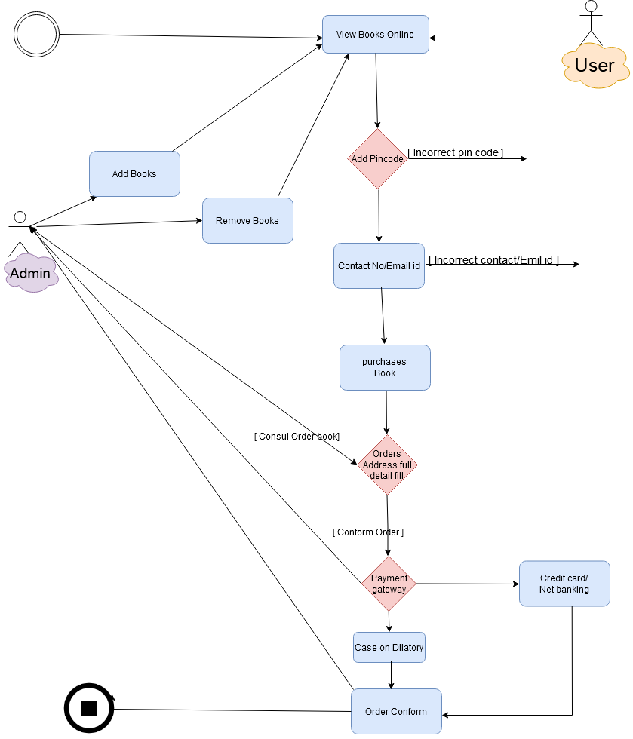

13. Draw Use case on online bill payment system (pay tm)

**14. Write SDLC phases with basic introduction**

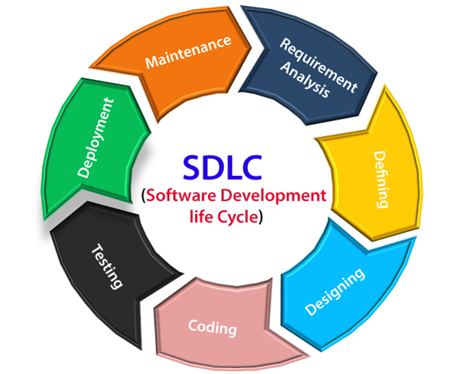

* SDLC Phases
* Requirements Collection/Gathering

Establish Customer Needs than Business Analyst Collects the requirement from the customer and provide the project Development team.

* Analysis

Model and specify the requirements- **What**”

Details on computer programming languages and environments, machines, packages, application architecture, distributed architecture layering, memory size, platform, algorithms, data structures, global type definitions, interfaces, and many other engineering details are established.

* Design

Model and specify a solution **-“Why”**

This phase only for project blue print design not coding

* Implementation

Construct a solution in software source code, product development, documentation in implementation phase

* Testing

Validate the solution against the requirements

* Maintenance

Repair defects and adapt the solution to the new requirement example whatsapp, fb

* Three Types of Maintenance

1. Corrective Maintenance

Identifying and repairing defects Example whatsapp photo first application in market not sand photo clarity than whatsapp as corrective and option document

1. Adaptive maintenance

Existing solution on the New Platform Example whatsapp, fb, telegram as application used in new platform is website

1. Perfective Maintenance

Implementation the new requirements in a spiral life cycle, everything after the deliver and deployment of the first prototype can be considered “maintenance” prototype can be considered “maintenance” Example whatsapp is new item add payment option

**15. Explain phases of the waterfall model**

